CO-2 AT-3
DEBUGGING AND OPTIMIZATION TASK
COURSE NAME: Design and Analysis of Algorithms (DAA)
COURSE CODE: CSA 0603
NAME: S. ALEX MADDY
REG: 192565060

Debugging Pair Sum Code (Same Element Allowed Through Incorrect Loop
Design)
The following brute force Pair Sum implementation may incorrectly use the same element
twice because of the way the inner loop is initialized and the missing restriction on pair
formation. Carefully analyze why this leads to invalid solutions when the target equals twice
the value of a single element. Debug the nested loops so that only distinct indices are
considered and each valid unordered pair is checked exactly once. Optimize the
implementation by avoiding redundant mirror comparisons. Analyze the time complexity of
the corrected solution and rewrite the final version with proper comments.

ERROR CODE:
def pair_sum(arr, target):
for i in range(len(arr)):
for j in range(i, len(arr)): # ERROR
if arr[i] + arr[j] == target:
return (i, j)
return None
OUTPUT OF THE FOLLOWING CODE:
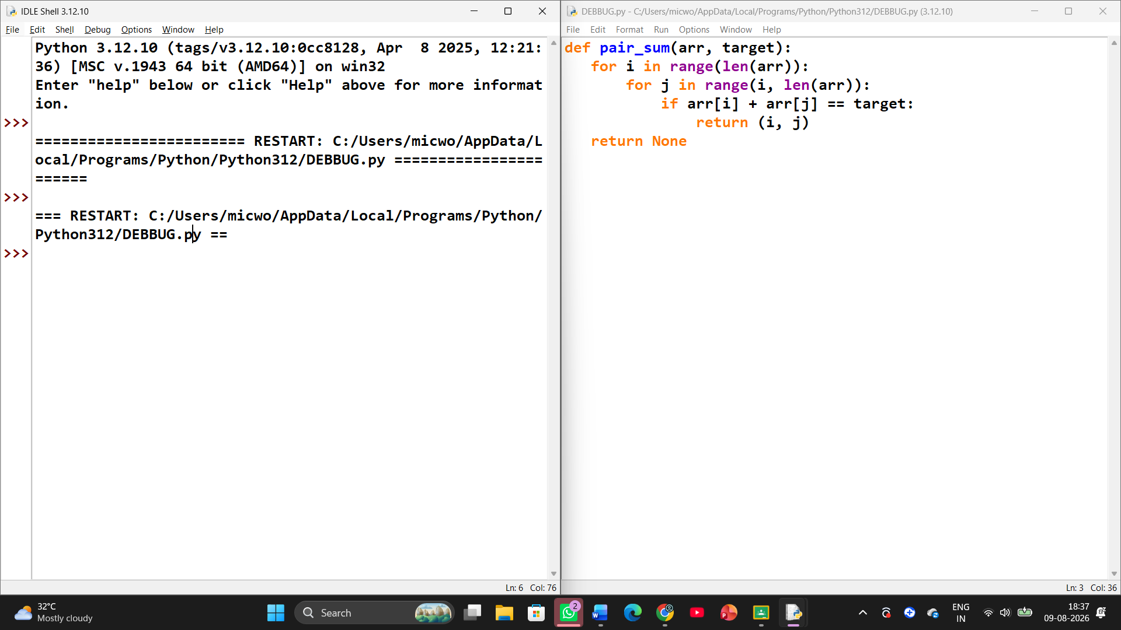

1. Problem in the given code
The error is in the inner loop:
for j in range(i, len(arr)):
Since j starts at i, the program allows i == j. This means the same array element can be used twice.
For example:
arr = [5, 2, 7]
target = 10
When i = 0 and j = 0:
arr[0] + arr[0] = 5 + 5 = 10
The program returns (0, 0), even though a pair should contain two distinct indices.

CORRECTED PYTHON CODE:
def pair_sum(arr, target):
# Traverse each element using index i
for i in range(len(arr)):

# Start j from i + 1 to ensure distinct indices
# and avoid checking the same unordered pair twice
for j in range(i + 1, len(arr)):

# Check whether the two different elements
# add up to the target
if arr[i] + arr[j] == target:
return (i, j)

# Return None if no valid pair is found
return None

# Example
arr = [2, 7, 11, 15]
target = 9

result = pair_sum(arr, target)
print("Pair indices:", result)

OUTPUT OF THE FOLLOWING CODE:
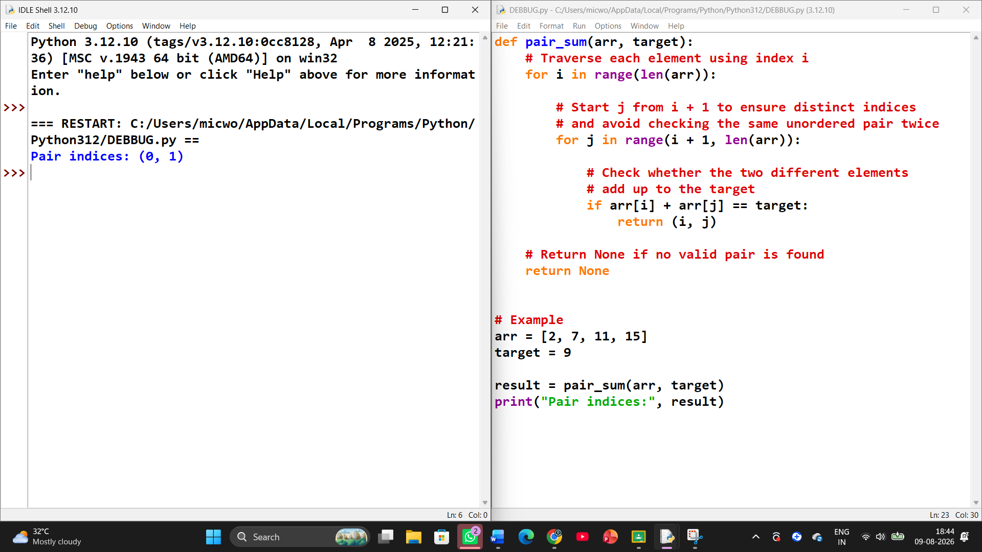
OPTIMIZING ALGORITHM EFFIENCY:
The original loop can compare an element with itself and may also perform unnecessary mirror comparisons if both (i, j) and (j, i) are considered.
Using:
range(i + 1, len(arr))
means that for an array of n elements, the program checks only:
unique pairs.
Time Complexity
The corrected brute-force solution has:
- Time Complexity: O(n²)
- Space Complexity: O(1)
The outer loop runs n times, while the inner loop checks progressively fewer elements.

